Docker concepts

Docker is a platform for developers and sysadmins to **develop, deploy, and run** applications with containers. The use of Linux containers to deploy applications is called *containerization*. Containers are not new, but their use for easily deploying applications is.

Containerization is increasingly popular because containers are:

* Flexible: Even the most complex applications can be containerized.
* Lightweight: Containers leverage and share the host kernel.
* Interchangeable: You can deploy updates and upgrades on-the-fly.
* Portable: You can build locally, deploy to the cloud, and run anywhere.
* Scalable: You can increase and automatically distribute container replicas.
* Stackable: You can stack services vertically and on-the-fly.

# **Docker overview**

*Estimated reading time: 10 minutes*

Docker is an open platform for developing, shipping, and running applications. Docker enables you to separate your applications from your infrastructure so you can deliver software quickly. With Docker, you can manage your infrastructure in the same ways you manage your applications. By taking advantage of Docker’s methodologies for shipping, testing, and deploying code quickly, you can significantly reduce the delay between writing code and running it in production.

## The Docker platform

Docker provides the ability to package and run an application in a loosely isolated environment called a container. The isolation and security allow you to run many containers simultaneously on a given host. Containers are lightweight because they don’t need the extra load of a hypervisor, but run directly within the host machine’s kernel. This means you can run more containers on a given hardware combination than if you were using virtual machines. You can even run Docker containers within host machines that are actually virtual machines!

Docker provides tooling and a platform to manage the lifecycle of your containers:

* Develop your application and its supporting components using containers.
* The container becomes the unit for distributing and testing your application.
* When you’re ready, deploy your application into your production environment, as a container or an orchestrated service. This works the same whether your production environment is a local data center, a cloud provider, or a hybrid of the two.

## ****What is Virtualization?****

Virtualization is the technique of importing a Guest operating system on top of a Host operating system. This technique was a revelation at the beginning because it allowed developers to run multiple operating systems in different virtual machines all running on the same host. This eliminated the need for extra hardware resource. The advantages of Virtual Machines or Virtualization are:

* Multiple operating systems can run on the same machine
* Maintenance and Recovery were easy in case of failure conditions
* Total cost of ownership was also less due to the reduced need for infrastructure

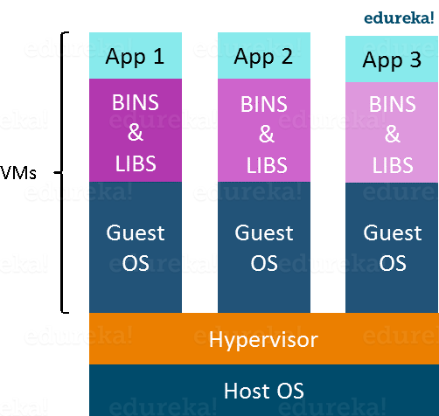

In the diagram on the right, you can see there is a host operating system on which there are 3 guest operating systems running which is nothing but the virtual machines.

As you know nothing is perfect, Virtualization also has some shortcomings. Running multiple Virtual Machines in the same host operating system leads to performance degradation. This is because of the guest OS running on top of the host OS, which will have its own kernel and set of libraries and dependencies. This takes up a large chunk of system resources, i.e. hard disk, processor and especially RAM.

Another problem with Virtual Machines which uses virtualization is that it takes almost a minute to boot-up. This is very critical in case of real-time applications.

Following are the disadvantages of Virtualization:

* Running multiple Virtual Machines leads to unstable performance
* Hypervisors are not as efficient as the host operating system
* Boot up process is long and takes time

These drawbacks led to the emergence of a new technique called Containerization. Now let me tell you about Containerization.

## ****What is Containerization?****

Containerization is the technique of bringing virtualization to the operating system level. While Virtualization brings abstraction to the hardware, Containerization brings abstraction to the operating system. Do note that Containerization is also a type of Virtualization. Containerization is however more efficient because there is no guest OS here and utilizes a host’s operating system, share relevant libraries & resources as and when needed unlike virtual machines. Application specific binaries and libraries of containers run on the host kernel, which makes processing and execution very fast. Even booting-up a container takes only a fraction of a second. Because all the containers share, host operating system and holds only the application related binaries & libraries. They are lightweight and faster than Virtual Machines.

### **Advantages of Containerization over Virtualization:**

* Containers on the same OS kernel are lighter and smaller
* Better resource utilization compared to VMs
* Boot-up process is short and takes few seconds

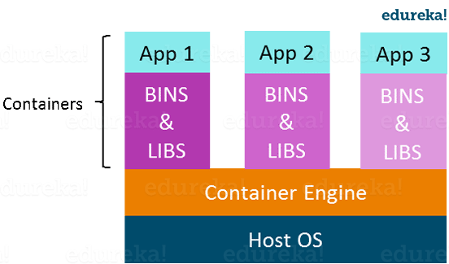

## ****Introduction To Docker****

Docker is a containerization platform that packages your application and all its dependencies together in the form of Containers to ensure that your application works seamlessly in any environment.

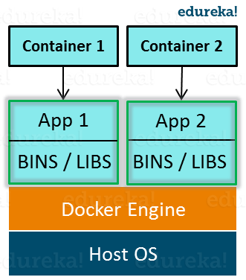

As you can see in the diagram on the right, each application will run on a separate container and will have its own set of libraries and dependencies. This also ensures that there is process level isolation, meaning each application is independent of other applications, giving developers surety that they can build applications that will not interfere with one another.

As a developer, I can build a container which has different applications installed on it and give it to my QA team who will only need to run the container to replicate the developer environment.

## ****Benefits of Docker****

Now, the QA team need not install all the dependent software and applications to test the code and this helps them save lots of time and energy. This also ensures that the working environment is consistent across all the individuals involved in the process, starting from development to deployment. The number of systems can be scaled up easily and the code can be deployed on them effortlessly.

## ****Virtualization vs Containerization****

Virtualization and Containerization both let you run multiple operating systems inside a host machine.

Virtualization deals with creating many operating systems in a single host machine. Containerization on the other hand will create multiple containers for every type of application as required.

As we can see from the image, the major difference is that there are multiple Guest Operating Systems in Virtualization which are absent in Containerization. The best part of Containerization is that it is very lightweight as compared to the heavy virtualization.

Docker Architecture:

## 

## Virtualisation Architecture:

## 

## Docker Engine

Docker Engine is a client-server application with these major components:

* A server which is a type of long-running program called a daemon process (the dockerdcommand).
* A REST API which specifies interfaces that programs can use to talk to the daemon and instruct it what to do.
* A command line interface (CLI) client (the docker command).

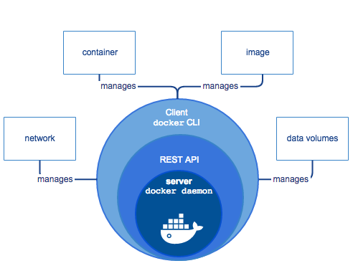

The CLI uses the Docker REST API to control or interact with the Docker daemon through scripting or direct CLI commands. Many other Docker applications use the underlying API and CLI.

The daemon creates and manages Docker objects, such as images, containers, networks, and volumes.

**Note**: Docker is licensed under the open source Apache 2.0 license.

For more details, see [Docker Architecture](https://docs.docker.com/engine/docker-overview/#docker-architecture) below.

## What can I use Docker for?

**Fast, consistent delivery of your applications**

Docker streamlines the development lifecycle by allowing developers to work in standardized environments using local containers which provide your applications and services. Containers are great for continuous integration and continuous delivery (CI/CD) workflows.

Consider the following example scenario:

* Your developers write code locally and share their work with their colleagues using Docker containers.
* They use Docker to push their applications into a test environment and execute automated and manual tests.
* When developers find bugs, they can fix them in the development environment and redeploy them to the test environment for testing and validation.
* When testing is complete, getting the fix to the customer is as simple as pushing the updated image to the production environment.

**Responsive deployment and scaling**

Docker’s container-based platform allows for highly portable workloads. Docker containers can run on a developer’s local laptop, on physical or virtual machines in a data center, on cloud providers, or in a mixture of environments.

Docker’s portability and lightweight nature also make it easy to dynamically manage workloads, scaling up or tearing down applications and services as business needs dictate, in near real time.

**Running more workloads on the same hardware**

Docker is lightweight and fast. It provides a viable, cost-effective alternative to hypervisor-based virtual machines, so you can use more of your compute capacity to achieve your business goals. Docker is perfect for high density environments and for small and medium deployments where you need to do more with fewer resources.

## Docker architecture

Docker uses a client-server architecture. The Docker client talks to the Docker daemon, which does the heavy lifting of building, running, and distributing your Docker containers. The Docker client and daemon can run on the same system, or you can connect a Docker client to a remote Docker daemon. The Docker client and daemon communicate using a REST API, over UNIX sockets or a network interface.

### **The Docker daemon**

The Docker daemon (dockerd) listens for Docker API requests and manages Docker objects such as images, containers, networks, and volumes. A daemon can also communicate with other daemons to manage Docker services.

### **The Docker client**

The Docker client (docker) is the primary way that many Docker users interact with Docker. When you use commands such as docker run, the client sends these commands to dockerd, which carries them out. The docker command uses the Docker API. The Docker client can communicate with more than one daemon.

### **Docker registries**

A Docker registry stores Docker images. Docker Hub is a public registry that anyone can use, and Docker is configured to look for images on Docker Hub by default. You can even run your own private registry. If you use Docker Datacenter (DDC), it includes Docker Trusted Registry (DTR).

When you use the docker pull or docker run commands, the required images are pulled from your configured registry. When you use the docker push command, your image is pushed to your configured registry.

### **Docker objects**

When you use Docker, you are creating and using images, containers, networks, volumes, plugins, and other objects. This section is a brief overview of some of those objects.

#### **IMAGES**

An image is a read-only template with instructions for creating a Docker container. Often, an image is based on another image, with some additional customization. For example, you may build an image which is based on the ubuntu image, but installs the Apache web server and your application, as well as the configuration details needed to make your application run.

You might create your own images or you might only use those created by others and published in a registry. To build your own image, you create a Dockerfile with a simple syntax for defining the steps needed to create the image and run it. Each instruction in a Dockerfile creates a layer in the image. When you change the Dockerfile and rebuild the image, only those layers which have changed are rebuilt. This is part of what makes images so lightweight, small, and fast, when compared to other virtualization technologies.

#### **CONTAINERS**

A container is a runnable instance of an image. You can create, start, stop, move, or delete a container using the Docker API or CLI. You can connect a container to one or more networks, attach storage to it, or even create a new image based on its current state.

By default, a container is relatively well isolated from other containers and its host machine. You can control how isolated a container’s network, storage, or other underlying subsystems are from other containers or from the host machine.

A container is defined by its image as well as any configuration options you provide to it when you create or start it. When a container is removed, any changes to its state that are not stored in persistent storage disappear.

##### **Example docker run command**

The following command runs an ubuntu container, attaches interactively to your local command-line session, and runs /bin/bash.

$ docker run -i -t ubuntu /bin/bash

When you run this command, the following happens (assuming you are using the default registry configuration):

1. If you do not have the ubuntu image locally, Docker pulls it from your configured registry, as though you had run docker pull ubuntu manually.
2. Docker creates a new container, as though you had run a docker container create command manually.
3. Docker allocates a read-write filesystem to the container, as its final layer. This allows a running container to create or modify files and directories in its local filesystem.
4. Docker creates a network interface to connect the container to the default network, since you did not specify any networking options. This includes assigning an IP address to the container. By default, containers can connect to external networks using the host machine’s network connection.
5. Docker starts the container and executes /bin/bash. Because the container is running interactively and attached to your terminal (due to the -i and -t flags), you can provide input using your keyboard while the output is logged to your terminal.
6. When you type exit to terminate the /bin/bash command, the container stops but is not removed. You can start it again or remove it.

#### **SERVICES**

Services allow you to scale containers across multiple Docker daemons, which all work together as a swarm with multiple managers and workers. Each member of a swarm is a Docker daemon, and the daemons all communicate using the Docker API. A service allows you to define the desired state, such as the number of replicas of the service that must be available at any given time. By default, the service is load-balanced across all worker nodes. To the consumer, the Docker service appears to be a single application. Docker Engine supports swarm mode in Docker 1.12 and higher.

## The underlying technology

Docker is written in [Go](https://golang.org/) and takes advantage of several features of the Linux kernel to deliver its functionality.

### **Namespaces**

Docker uses a technology called namespaces to provide the isolated workspace called the container. When you run a container, Docker creates a set of namespaces for that container.

These namespaces provide a layer of isolation. Each aspect of a container runs in a separate namespace and its access is limited to that namespace.

Docker Engine uses namespaces such as the following on Linux:

* **The pid namespace:** Process isolation (PID: Process ID).
* **The net namespace:** Managing network interfaces (NET: Networking).
* **The ipc namespace:** Managing access to IPC resources (IPC: InterProcess Communication).
* **The mnt namespace:** Managing filesystem mount points (MNT: Mount).
* **The uts namespace:** Isolating kernel and version identifiers. (UTS: Unix Timesharing System).

### **Control groups**

Docker Engine on Linux also relies on another technology called control groups (cgroups). A cgroup limits an application to a specific set of resources. Control groups allow Docker Engine to share available hardware resources to containers and optionally enforce limits and constraints. For example, you can limit the memory available to a specific container.

### **Union file systems**

Union file systems, or UnionFS, are file systems that operate by creating layers, making them very lightweight and fast. Docker Engine uses UnionFS to provide the building blocks for containers. Docker Engine can use multiple UnionFS variants, including AUFS, btrfs, vfs, and DeviceMapper.

### **Container format**

Docker Engine combines the namespaces, control groups, and UnionFS into a wrapper called a container format. The default container format is libcontainer. In the future, Docker may support other container formats by integrating with technologies such as BSD Jails or Solaris Zones

### **containerd**

containerd is an industry-standard container runtime with an emphasis on simplicity, robustness and portability. It is available as a daemon for Linux and Windows, which can manage the complete container lifecycle of its host system: image transfer and storage, container execution and supervision, low-level storage and network attachments, etc.

containerd is designed to be embedded into a larger system, rather than being used directly by developers or end-users.

### **RunC**

RunC is a container runtime originally developed as part of Docker and later extracted out as a separate open source tool and library. As a “low level” container runtime, runC is mainly used by “high level” container runtimes (e.g. Docker) to spawn and run containers, although it can be used as a stand-alone tool.